THE EUROPEAN CENTRAL BANK
Customer Engagement & Product
Utilization Analytics for Retention Strategy
A Behavioral & Relationship-Depth Analysis of Customer Churn
RESEARCH PAPER
Prepared for Unified Mentor — The European Central Bank
Dataset: European_Bank.csv | 10,000 Retail Banking Customers | France, Germany, Spain
July 2026

Table of Contents
Table of Contents 2
Executive Summary 4
1. Background and Context 5
2. Problem Statement 5
3. Project Objectives 5
Primary Objectives 5
Secondary Objectives 6
4. Data Description & Validation 7
Validation Results 7
5. Analytical Methodology 8
Stage 1 — Data Ingestion & Validation 8
Stage 2 — Engagement Classification 8
Stage 3 — Product Utilization Analysis 8
Stage 4 — Financial Commitment vs. Engagement Analysis 8
Stage 5 — Retention Strength Assessment 8
6. Findings 9
6.1 Overall Churn Landscape 9
6.2 Engagement Classification 10
6.3 Product Utilization Analysis — The Product Depth Paradox 11
6.4 Financial Commitment vs. Engagement Analysis 12
6.5 Retention Strength Assessment — The Relationship Strength Index 13
6.6 Supporting Demographic & Geographic Patterns 14
7. Key Performance Indicators 16
Interpretation 16
8. Recommendations 17
8.1 Engagement-Driven Retention Initiatives 17
8.2 Product Bundling Strategy 17
8.3 Loyalty Program Design 17
8.4 Monitoring & Governance 17
9. Conclusion 18
Appendix A: Segment & KPI Definitions 19
Engagement Profiles 19
Relationship Strength Index (RSI) Scoring Rule 19
High-Balance Threshold 19
Appendix B: Supplementary Statistical Tables 20
Balance & Product Averages by Outcome 20
Churn Rate by Age Band (Full Detail) 20

Executive Summary
This research paper examines 10,000 retail banking customers across France, Germany, and Spain to test a central hypothesis: that engagement and product depth — not wealth or demographics — are the true drivers of customer retention. The analysis confirms this hypothesis decisively and quantifies it through five behavioral Key Performance Indicators (KPIs).
Overall portfolio churn stands at 20.4% (2,037 customers). Inactive members churn at 26.9%, nearly 1.9 times the rate of active members (14.3%). Product depth shows a striking non-linear pattern: customers holding two products churn at just 7.6% — the healthiest tier in the portfolio — while customers holding three or more products churn at 85.9%, a signal of distressed, over-exposed relationships rather than loyalty. Nearly half of all high-balance customers (49.9%) are disengaged, and this inactive-premium segment alone holds 24.3% of total portfolio deposits — confirming that balance size provides no inherent protection against silent churn. A composite Relationship Strength Index (RSI) built from engagement, product tier, card ownership, and tenure shows a near-perfect gradient, from 96% churn at the weakest score to just 5% churn at the strongest.
These findings reframe retention strategy: rather than targeting customers by balance or salary, the Bank should prioritize activity-based engagement programs, a two-product bundling target, and proactive monitoring of disengaged premium accounts. Full recommendations are detailed in Section 8.

1. Background and Context
Retail banks have historically approached customer retention through a demographic and financial lens — segmenting customers by age, income, or account balance and assuming that financially strong customers are inherently loyal. In practice, this assumption breaks down repeatedly: customers with high balances or strong salaries still churn when they feel disengaged, underserved, or poorly matched to the bank's product suite.
This project reframes retention analysis around customer behavior and relationship depth rather than demographics alone. It treats engagement (measured through account activity) and product utilization (measured through the number and mix of products held) as the primary lenses through which churn should be understood, evaluated, and acted upon.
The findings are intended to directly inform three areas of commercial decision-making at the Bank:
- Cross-sell strategy — identifying which product combinations strengthen, rather than strain, the customer relationship.
- Loyalty programs — targeting the behavioral triggers (activity, tenure, product mix) that most reliably predict retention.
- Engagement-driven retention initiatives — surfacing customers who look financially healthy on paper but are quietly disengaging.

2. Problem Statement
Despite holding rich data on customer engagement and product usage, banks frequently lack three things:
- Quantitative insight into which specific behaviors — activity, product count, product mix, tenure — actually drive churn, as opposed to being assumed to matter.
- Clarity on product depth — whether holding more products genuinely deepens loyalty, or whether it can also signal an over-sold, distressed relationship.
- Evidence on balance and income — whether high balances or salaries provide any real insulation against attrition, or whether they mask disengagement ("silent churn").
In the absence of this evidence, retention strategies default to generic, demographic-led programs (e.g., "target high-balance customers") that are frequently misaligned with the behaviors that actually predict churn. This paper closes that gap using a full-portfolio statistical analysis of the Bank's customer base.

3. Project Objectives

Primary Objectives
- Evaluate the relationship between customer engagement (activity status) and churn.
- Measure the retention impact of product count and product mix.
- Identify disengaged yet high-value (high-balance) customers who represent silent churn risk.

Secondary Objectives
- Support the design of engagement-driven retention strategies.
- Improve product bundling decisions based on evidence rather than assumption.
- Reduce silent churn among premium (high-balance) customers.

4. Data Description & Validation
The analysis is based on a full-portfolio extract of 10,000 retail banking customers, provided as European_Bank.csv. Each row represents one customer relationship as of the extract date.
Column | Description
CustomerId | Unique customer identifier
Surname | Customer surname
CreditScore | Customer creditworthiness (350–850)
Geography | Country of residence: France, Spain, or Germany
Gender | Male / Female
Age | Customer age in years (18–92)
Tenure | Years as a customer of the Bank (0–10)
Balance | Current account balance (EUR)
NumOfProducts | Number of Bank products held (1–4)
HasCrCard | Credit card ownership (binary)
IsActiveMember | Activity indicator (binary)
EstimatedSalary | Estimated annual salary (EUR)
Exited | Churn indicator — target variable (binary)

Validation Results
- Completeness: Zero missing values across all 14 fields and 10,000 records.
- Uniqueness: All 10,000 CustomerId values are unique — no duplicate customer records.
- Binary field consistency: HasCrCard, IsActiveMember, and Exited each contain only the values {0, 1}, confirmed across the full dataset.
- Categorical integrity: Geography is restricted to exactly three expected values (France, Germany, Spain); Gender to exactly two (Male, Female).
- Range checks: CreditScore (350–850), Age (18–92), Tenure (0–10 years), and NumOfProducts (1–4) all fall within plausible banking ranges with no negative values or impossible outliers.
- Churn labeling: Exited is well-balanced enough for reliable subgroup analysis — 20.37% positive class (2,037 churned customers) versus 79.63% retained (7,963 customers).
The dataset required no imputation, deduplication, or corrective transformation prior to analysis. Two derived fields were engineered to support the engagement-focused methodology: a High-Balance flag (customers in the top quartile of account balance, ≥ €127,644) and a Relationship Strength Index (described in Section 6.5).
5. Analytical Methodology
The analysis follows a five-stage methodology moving from data integrity through to a composite retention-strength score:

Stage 1 — Data Ingestion & Validation
Loading and validating the dataset, confirming binary-field consistency, categorical integrity, and churn-label accuracy (detailed in Section 4).

Stage 2 — Engagement Classification
Customers are grouped into four behavioral profiles based on activity status and product/balance context: Active Engaged (multi-product), Active but Low-Product, Inactive High-Balance, and Inactive Disengaged. This reframes the portfolio away from a single active/inactive split toward profiles that combine engagement with financial context.

Stage 3 — Product Utilization Analysis
Churn rate is measured at each product-count tier (1 through 4) and rolled up into single-product versus multi-product cohorts, to test whether product depth uniformly improves retention or whether the relationship is non-linear.

Stage 4 — Financial Commitment vs. Engagement Analysis
Account balance is cross-tabulated against activity status to isolate an "at-risk premium" segment — high-balance customers who are not actively engaged — and to test for salary–balance mismatches that might signal an under-utilized relationship.

Stage 5 — Retention Strength Assessment
A composite Relationship Strength Index (RSI) combines activity, product tier, card ownership, and tenure into a single 0–6 score, which is then tested against churn to confirm whether relationship depth — rather than any single factor — is the more reliable predictor of retention.
All churn rates reported below are simple conditional means (observed churn rate = count of Exited=1 ÷ count of records) within each named subgroup, computed directly from the full 10,000-record dataset — no sampling or modeling assumptions were applied at this stage.

6. Findings
This section presents results in the order defined by the methodology: overall churn context, engagement classification, product utilization, financial commitment versus engagement, retention strength, and finally supporting demographic patterns.

6.1 Overall Churn Landscape
Of the 10,000 customers in the portfolio, 2,037 (20.4%) churned during the observation period, against a retained base of 7,963 (79.6%). This baseline rate is the reference point against which every subgroup finding below should be read — a subgroup materially above 20.4% represents elevated risk, while one materially below it represents a protective factor.
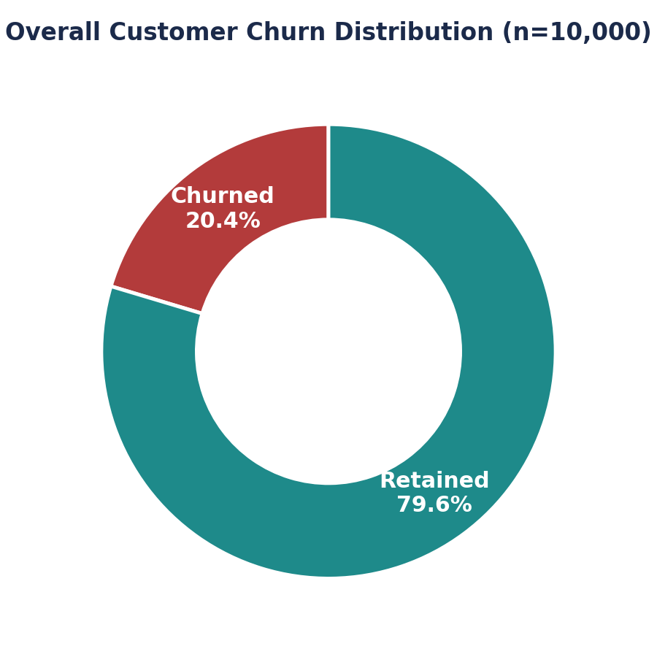
Figure 1. Overall customer churn distribution (n = 10,000).

6.2 Engagement Classification
Customers were grouped into four profiles combining activity status with product depth and balance context (see Appendix A for exact definitions):
Engagement Profile | Customers | Churn Rate
Active Engaged (Multi-Product) | 2,588 | 9.7%
Active, Low-Product | 2,563 | 18.9%
Inactive, High-Balance | 1,247 | 30.5%
Inactive, Disengaged | 3,602 | 25.6%

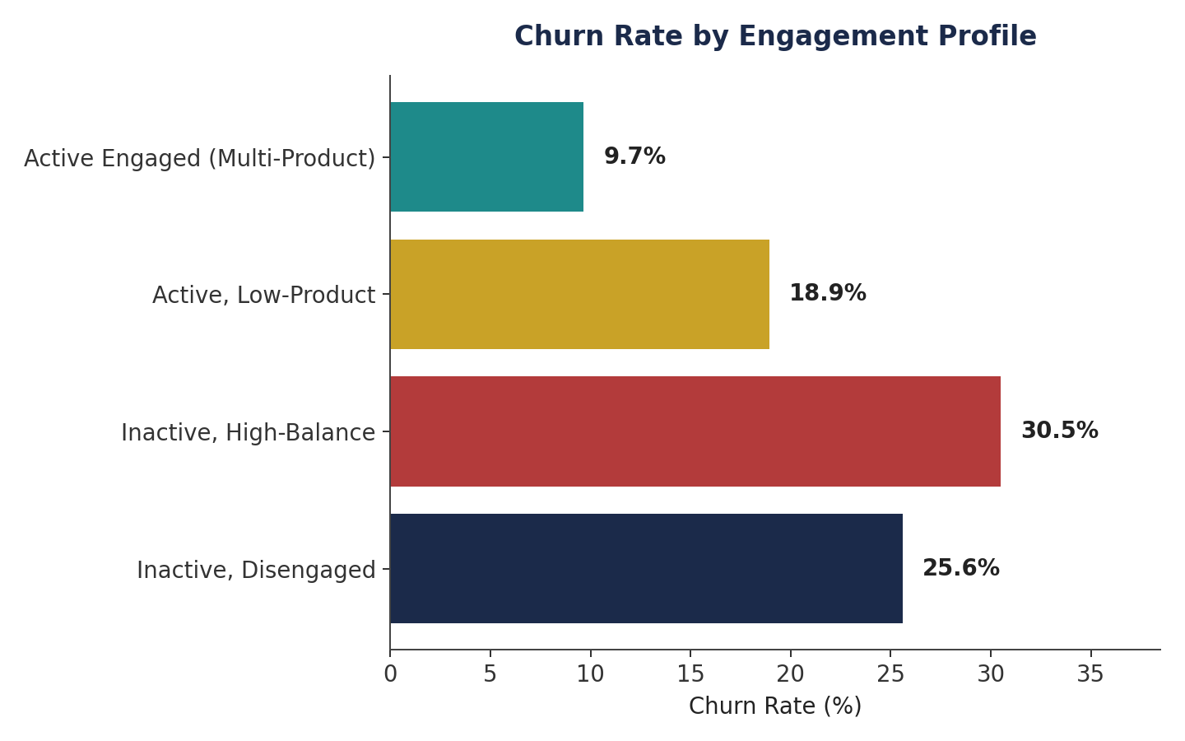
Figure 2. Churn rate by engagement profile.
The gap between the strongest and weakest profiles is stark: Active Engaged customers churn at 9.7%, roughly one-third the rate of Inactive High-Balance customers at 30.5%. Critically, the single largest profile by headcount is Inactive, Disengaged (3,602 customers, 36% of the portfolio), churning at 25.6% — well above baseline. Engagement status alone separates the healthiest and highest-risk cohorts more cleanly than any single demographic variable tested in this study.

6.3 Product Utilization Analysis — The Product Depth Paradox
A naive assumption would hold that more products sold means a deeper, stickier relationship. The data reject this assumption outright, revealing instead a sharp non-linear "paradox":
Products Held | Customers | Churn Rate
1 product | 5,084 | 27.7%
2 products | 4,590 | 7.6%
3 products | 266 | 82.7%
4 products | 60 | 100.0%

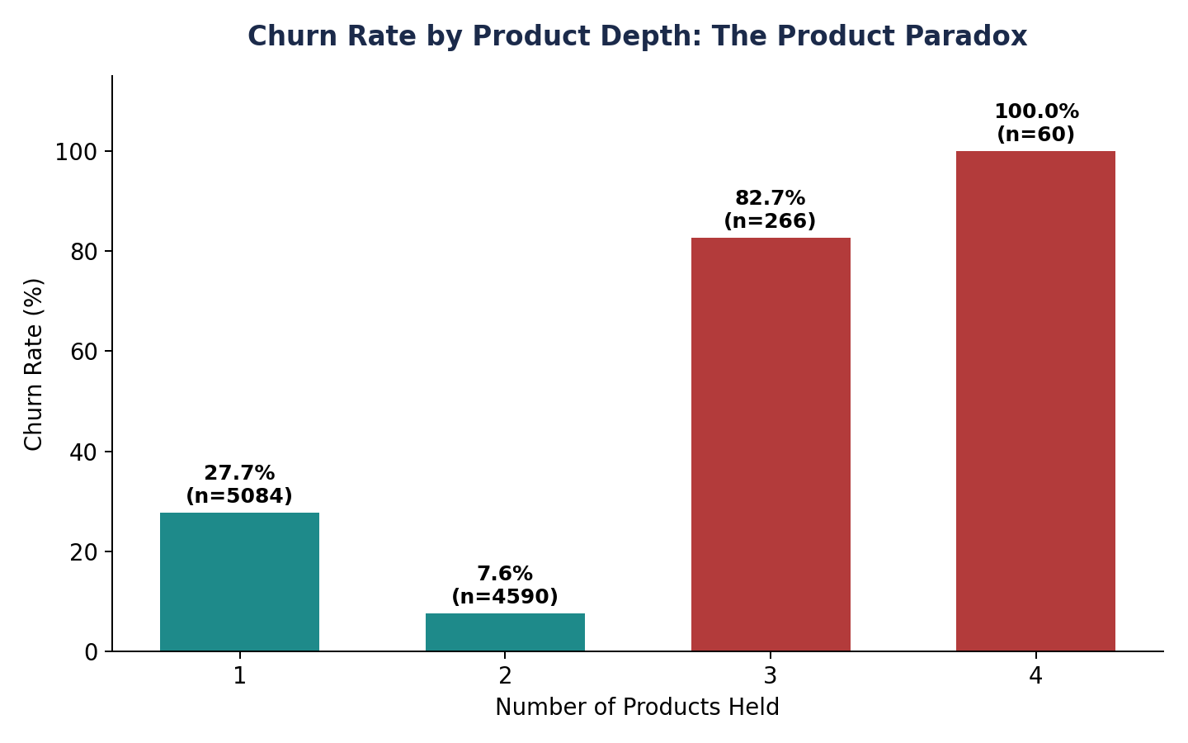
Figure 3. Churn rate by number of products held — note the inflection at three products.
Retention improves substantially from one product (27.7% churn) to two products (7.6% churn) — a 72% relative reduction in churn risk and the single strongest product-tier effect in the dataset. But the pattern inverts violently beyond two products: the 326 customers holding three or more products churn at 85.9%, including a 100% churn rate among the 60 four-product holders. This is not a story of "more products, more loyalty" — it is far more consistent with over-exposed or distressed relationships: customers issued additional products late in a soured relationship (e.g., as a retention or cross-sell push after dissatisfaction had already set in), or product bundles that created servicing friction rather than value.
Methodological note: Because this relationship is U-shaped rather than linear, a standard linear correlation between NumOfProducts and churn is weak and misleading (Pearson r ≈ −0.05). Segment-level tabulation, not correlation, is required to detect this pattern — a caution that applies broadly whenever "more is better" is assumed for a behavioral variable.

6.4 Financial Commitment vs. Engagement Analysis
Using the top quartile of account balance (≥ €127,644) as a "high-balance" threshold, 49.9% of high-balance customers are inactive — essentially a coin flip. This directly tests, and disproves, the assumption that wealthier customers are automatically more engaged.
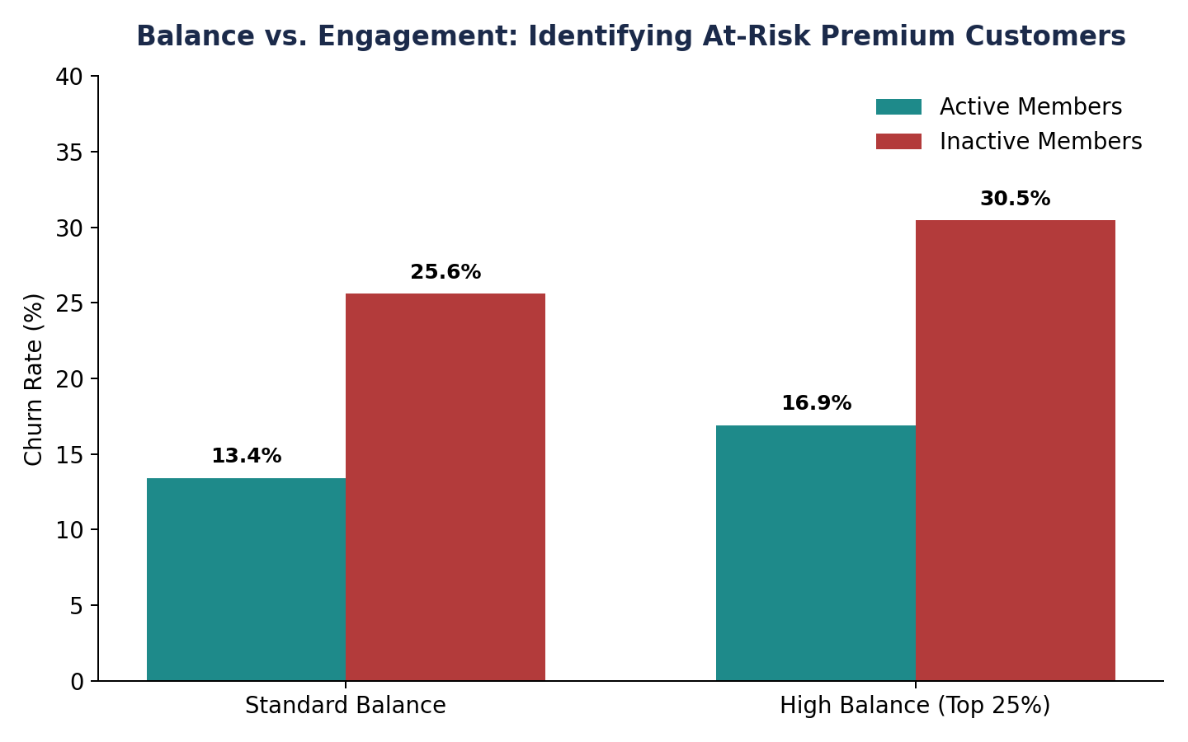
Figure 4. Churn rate by balance tier and engagement status.
Among high-balance customers, engagement — not the balance itself — determines outcome: active high-balance customers churn at 16.9%, while inactive high-balance customers churn at 30.5%, a gap of nearly 14 percentage points driven entirely by activity status. This 1,247-customer "at-risk premium" segment collectively holds €185.6 million — 24.3% of total portfolio deposits. Of these, 380 customers have already churned, representing roughly €56.9 million in departed balances. This is the clearest evidence of "silent churn": financially attractive customers who present no obvious warning sign apart from disengagement.
A secondary check for salary–balance mismatch (customers in the top salary quartile but bottom balance quartile — high earning capacity, low deposit commitment) identified 891 customers. Their churn rate, 14.8%, is actually below the portfolio average — suggesting this particular mismatch is not, on its own, a reliable churn signal, and that engagement status remains the more decisive variable.
More broadly, churned customers carried a higher average balance (€91,109) than retained customers (€72,745), and churn among customers with a non-zero balance (24.1%) is nearly double the rate among zero-balance customers (13.8%). Balance size, in isolation, is therefore not a protective factor against churn in this portfolio — if anything, the relationship runs the opposite direction.

6.5 Retention Strength Assessment — The Relationship Strength Index
To test whether relationship depth as a whole — rather than any single factor — best predicts retention, a composite Relationship Strength Index (RSI) was built on a 0–6 scale, awarding points for active membership, an optimal (two-product) holding, single-product holding, credit card ownership, and tenure of five years or more (full scoring rule in Appendix A).
RSI Score | Customers | Churn Rate
0 (weakest) | 25 | 96.0%
1 | 413 | 44.8%
2 | 1,537 | 35.8%
3 | 2,476 | 25.0%
4 | 2,492 | 15.7%
5 | 2,098 | 10.4%
6 (strongest) | 959 | 5.0%

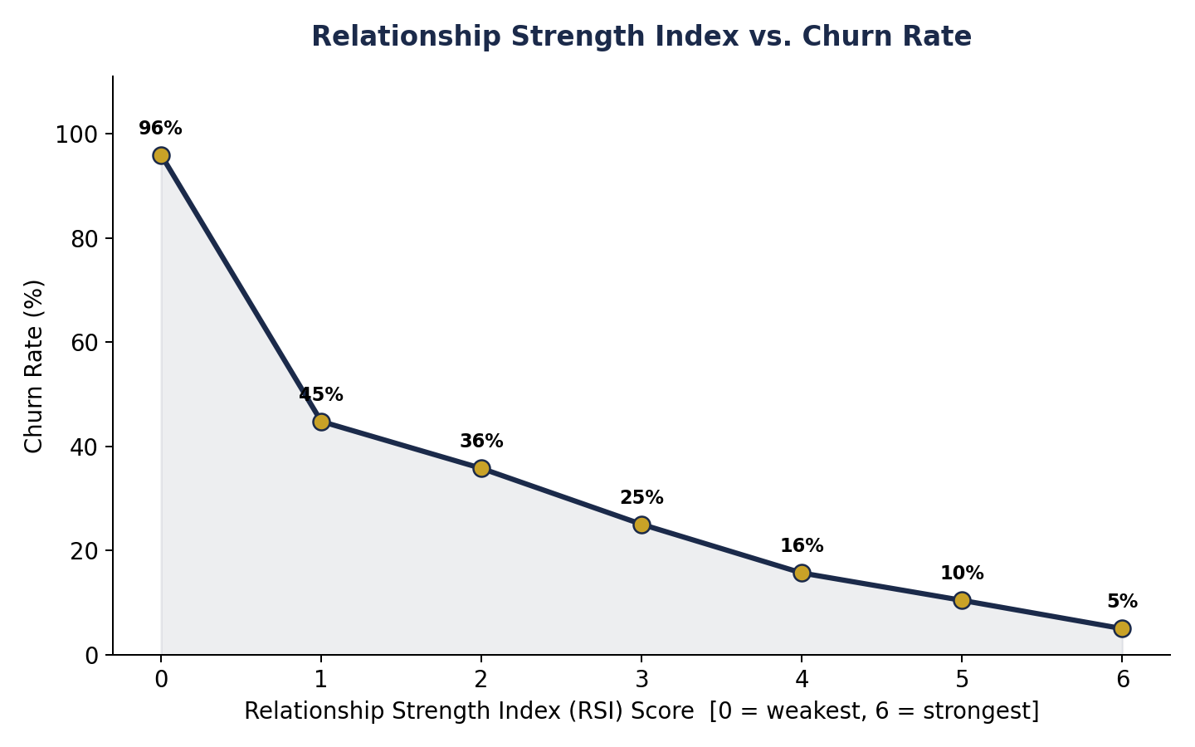
Figure 5. Relationship Strength Index vs. churn rate — a near-monotonic gradient.
The RSI produces the cleanest gradient in the entire study: churn falls in an almost perfectly monotonic staircase from 96.0% at the weakest score (0) to 5.0% at the strongest score (6). This confirms the project's central premise: retention is best explained by combined relationship depth, not any single behavioral or financial attribute in isolation. The RSI provides the Bank with a practical, immediately deployable scoring rule for prioritizing retention outreach.

6.6 Supporting Demographic & Geographic Patterns
While the project's core focus is behavioral, three demographic patterns are strong enough to merit inclusion as context for market-level retention planning:

Geography
Geography | Customers | Churn Rate
France | 5,014 | 16.2%
Spain | 2,477 | 16.7%
Germany | 2,509 | 32.4%

Germany churns at 32.4% — roughly double France (16.2%) and Spain (16.7%) — despite similar product and engagement mechanics. The product paradox is also sharpest in Germany: German customers holding three or more products churn at 91.7% (n=120), compared with France's already-elevated 78.8–100% range for the same tier. This suggests Germany-specific service, pricing, or competitive pressures compounding the behavioral risk factors identified above, and warrants a market-specific retention review.

Gender
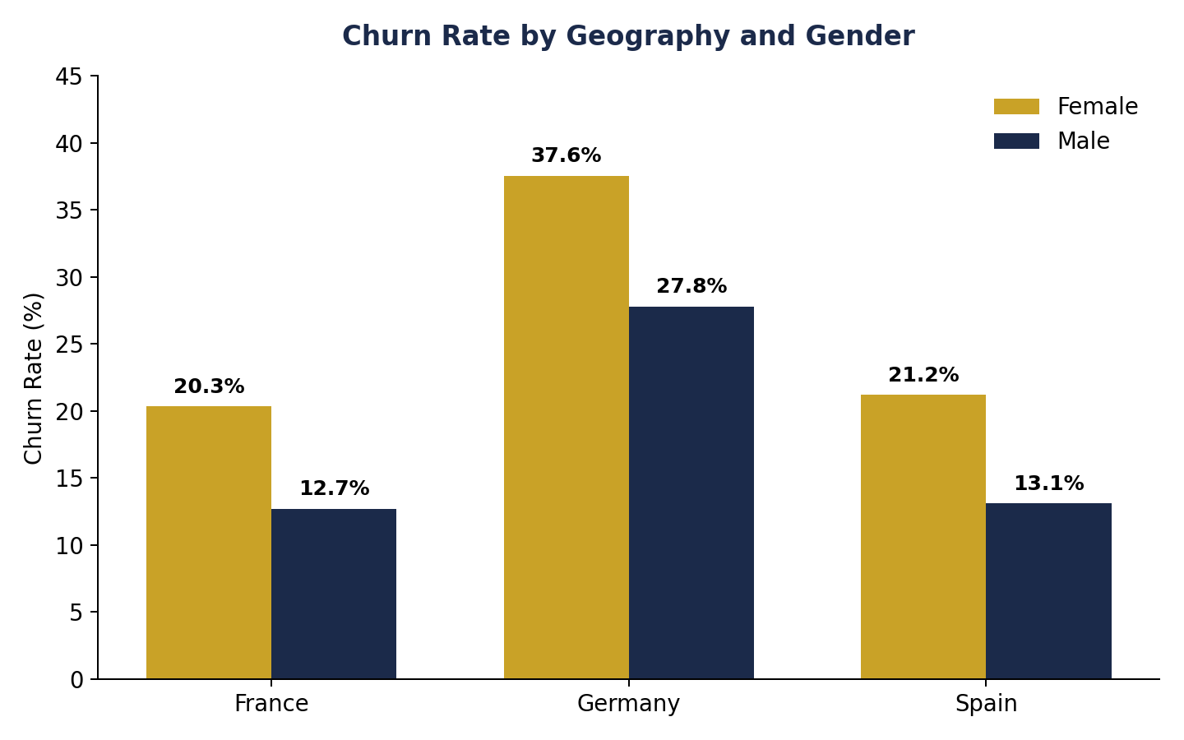
Figure 6. Churn rate by geography and gender.
Female customers churn more than male customers in every market studied (25.1% vs. 16.5% overall), with the gap widest in Germany (37.6% for women vs. 27.8% for men). This pattern is consistent enough across all three countries to warrant further qualitative research into service experience by gender, though it falls outside this paper's behavioral scope to explain.

Age
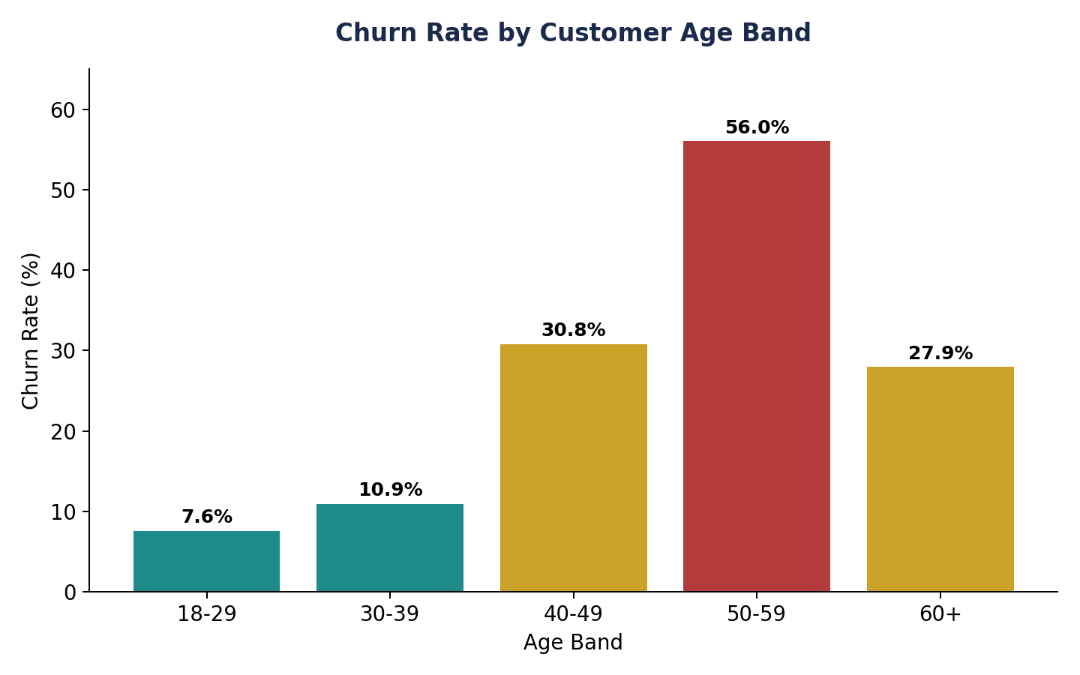
Figure 7. Churn rate by age band.
Churn rises sharply with age through mid-career, peaking at 56.0% in the 50–59 age band — nearly triple the youngest cohort's 7.6% — before falling back to 27.9% for customers aged 60 and over. This hump-shaped pattern (rather than a simple linear age effect) suggests the 45–59 age band, likely nearing major financial transitions such as retirement planning, is the single highest-priority age segment for retention attention.

7. Key Performance Indicators
Five KPIs were defined to translate the behavioral findings above into a monitoring framework the Bank can track on an ongoing basis.
KPI | Definition | Result
Engagement Retention Ratio | Churn rate of inactive customers ÷ churn rate of active customers | 1.88× (26.9% vs. 14.3%)
Product Depth Index | Churn rate at the optimal 2-product tier vs. the 3+-product tier | 7.6% vs. 85.9% (11.3× gap)
High-Balance Disengagement Rate | Share of top-quartile-balance customers who are inactive | 49.9% (1,247 customers)
Credit Card Stickiness Score | Churn rate (no card) − churn rate (card) | +0.6 pts (20.8% vs. 20.2%)
Relationship Strength Index | Composite 0–6 engagement/product/tenure score vs. churn | 96.0% (score 0) → 5.0% (score 6)

Interpretation
- Engagement Retention Ratio (1.88×): Inactivity is the single most reliable, and most actionable, churn signal available — nearly twice the risk of active customers. This KPI should anchor any early-warning dashboard.
- Product Depth Index (11.3× gap): Two products is the retention "sweet spot." Cross-sell targets should stop at two well-matched products rather than maximizing product count; a third or fourth product should trigger a relationship health review, not be treated as a success metric.
- High-Balance Disengagement Rate (49.9%): Roughly one in two premium customers is already disengaged. This KPI should be tracked monthly as a leading indicator of silent churn exposure, given it directly touches €185.6 million in portfolio deposits.
- Credit Card Stickiness Score (+0.6 pts): Card ownership has negligible retention value in this portfolio. The Bank should not rely on card issuance alone as a loyalty lever, and should redirect retention budget toward activity-driving initiatives instead.
- Relationship Strength Index (96% → 5%): The single most powerful predictor identified in this study. RSI is recommended as the primary scoring mechanism for retention outreach prioritization (see Section 8).

8. Recommendations

8.1 Engagement-Driven Retention Initiatives
- Deploy the Relationship Strength Index (RSI) as a live scoring field in the CRM, with automated outreach triggers for any customer scoring 0–2 (35.8%–96.0% observed churn range).
- Prioritize reactivation campaigns over acquisition spend for the 3,602 Inactive, Disengaged customers — the largest single profile in the portfolio at 36% of all customers.
- Build a specific "silent churn" alert for high-balance customers whose activity status changes from active to inactive, given the segment's outsized 24.3% share of total deposits.

8.2 Product Bundling Strategy
- Set a cross-sell target of two products per customer as the standard "healthy relationship" benchmark, rather than maximizing product count.
- Treat any move to a third or fourth product as a mandatory relationship-health review trigger rather than a pure sales win, given the 85.9% churn rate observed at that tier.
- Investigate the root cause of the three-plus product cohort directly (e.g., through customer interviews or complaint-log review) before designing further multi-product bundles, since the current data cannot distinguish over-selling from active dissatisfaction as the underlying cause.

8.3 Loyalty Program Design
- Anchor loyalty-tier qualification to engagement and relationship depth (RSI) rather than balance or salary thresholds, which this study found to be poor standalone predictors of loyalty.
- De-prioritize credit card issuance as a stand-alone loyalty lever given its negligible (+0.6 point) observed impact on retention; redirect the associated incentive budget toward activity-based rewards.
- Consider a differentiated German-market loyalty track, given churn roughly double that of France and Spain under otherwise similar product mechanics.

8.4 Monitoring & Governance
- Track all five KPIs in Section 7 on a monthly cadence via the accompanying Streamlit dashboard, with the High-Balance Disengagement Rate and RSI distribution as the two headline metrics for executive reporting.
- Re-run this analysis quarterly to confirm the product-depth paradox and RSI gradient remain stable as the Bank's product mix and market conditions evolve.

9. Conclusion
This analysis set out to test whether customer behavior and relationship depth explain retention better than demographic or financial strength alone. The evidence across 10,000 customers supports this reframing on every count tested: activity status separates low- and high-risk customers more cleanly than balance or salary; product depth shows a sharp non-linear "sweet spot" at two products rather than a simple more-is-better pattern; and a composite Relationship Strength Index outperforms any single variable as a churn predictor, moving from 96% to 5% churn across its range.
Perhaps the most consequential single finding for the Bank is the scale of silent churn risk: nearly half of all high-balance customers are disengaged, together holding close to a quarter of total portfolio deposits. Left unaddressed, this segment represents the Bank's single largest source of preventable, and largely invisible, revenue attrition.
The recommendations in Section 8 are designed to be implementable without new data collection — they rely entirely on fields already captured in the Bank's core systems (activity status, product holdings, tenure, card ownership) — allowing the Bank to move from insight to action immediately.

Appendix A: Segment & KPI Definitions

Engagement Profiles
- Active Engaged (Multi-Product): Is Active Member = 1 and Num of Products ≥ 2.
- Active, Low-Product: Is Active Member = 1 and Num of Products = 1.
- Inactive, High-Balance: Is Active Member = 0 and Balance in the top quartile (≥ €127,644).
- Inactive, Disengaged: Is Active Member = 0 and Balance below the top quartile.

Relationship Strength Index (RSI) Scoring Rule
RSI is a 0–6 additive score computed per customer as follows:
- +2 points if Is Active Member = 1
- +2 points if Num of Products = 2 (the optimal tier identified in Section 6.3)
- +1 point if Num of Products = 1
- +1 point if Has Cr Card = 1
- +1 point if Tenure ≥ 5 years
Note: three-and four-product holders receive 0 points from the product-tier component, consistent with their observed high-risk status; this is a deliberate design choice reflecting the Section 6.3 findings rather than an oversight.

High-Balance Threshold
Defined as the 75th percentile of account balance across the full portfolio (≥ €127,644), consistent with standard quartile-based premium-segment definitions.

Appendix B: Supplementary Statistical Tables

Balance & Product Averages by Outcome
Metric | Retained | Churned
Average Balance (EUR) | 72,745 | 91,109
Average Products Held | 1.54 | 1.48
Count | 7,963 | 2,037

Churn Rate by Age Band (Full Detail)
Age Band | Customers | Churn Rate
18–29 | 1,641 | 7.6%
30–39 | 4,346 | 10.9%
40–49 | 2,618 | 30.8%
50–59 | 869 | 56.0%
60+ | 526 | 27.9%

Data source: European_Bank.csv (10,000 records, single extract, no missing values). All figures in this paper are computed directly from the full dataset; no sampling, weighting, or predictive modeling was applied — all reported percentages are observed conditional churn rates within the stated subgroup.

